(Approx. 316 words)

Back to Basics
Quiz on File Extensions
Jim Cerny, Help Desk Host
Sarasota Technology Users Group
June 2021 issue, STUGMonitor
www.stug.org
jimcerny123 (at) gmail.com

All Windows computers can work with many different types of files. Some files contain text, some photos, others videos. To help computers – and us humans too – every file has, as part of the file name, an “extension” of three or four letters at the end of the file name that identifies what kind of file it is. On Windows, if you open the “File Explorer” app, you will get a window that allows you to see all the files on your computer. If you “hover” your mouse over a file name, it will show you the kind of file it is – a text file, Word document, spreadsheet, etc. If you go to the “View” menu option on File Explorer, there is a little box you can check to turn on “File name extensions” so you will always see them. Since you cannot play a video file in a Word document or listen to an audio file using the Paint app, it is helpful to understand what a file extension means and what apps can work with them. Of course, you can always “Ask Google” about any file extension and get help that way too. But just for fun, how many of the following file types do you know? Can you match them up correctly? (HINT: The answer letter “L” is matched to three different file types.

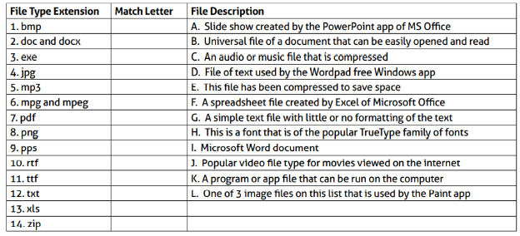
Need a hint or some help? The Paint app comes free with Windows and can work with or open several different image file types. Microsoft Word can open several different text file types too. Text formatting allows additional enhancements to text such as underline, bold, color, etc.

How was that? Helpful or more confusing? Well, here are the — ANSWERS
(Do not peek until you are ready!)

